Emoji App Test based on Android

Recently we have test our EC601 Final Project emoji app in AWS, here are the results:

1. Overview:

As the pictures showing below, the test results are positive. All the tests have been passed and we have chosen the most popular Android mobile phones nowadays as our test platform, which basically contains all the Android version indicated by AWS. The mobile phones include Amazon Kindle Fire HDX 7, LG G Pad 7.0 (AT&T), Samsung Galaxy S5 (T-Mobile), S6 (Verizon) and Tab 4 10.1 (WIFI).

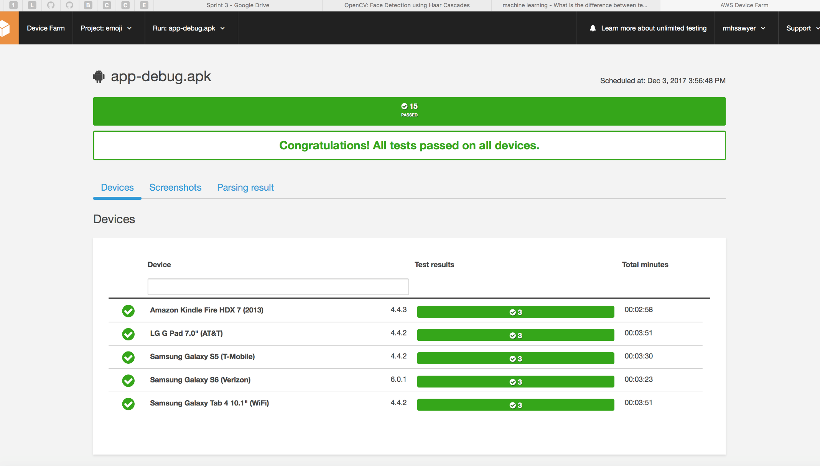

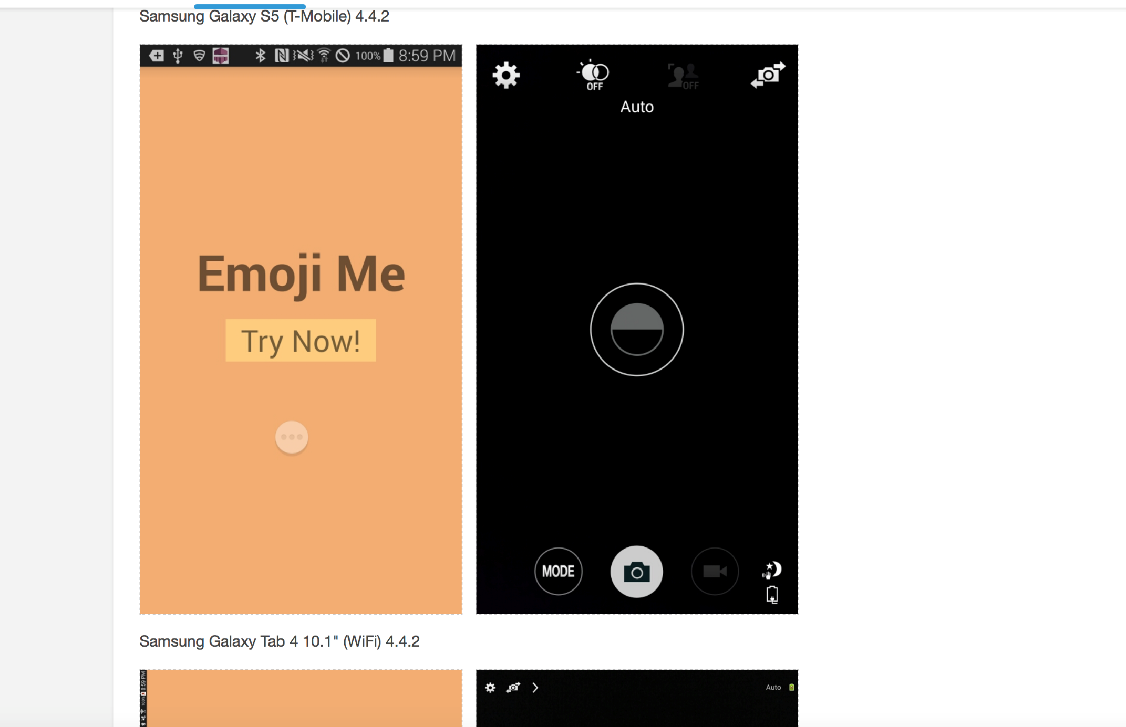

1. Test Details:

We randomly opened Samsung Galaxy S5 (T-Mobile) test page as our example to show what the test includes. The total test parts are: Video, Suites, Logs, Performance, Files, Screenshots.

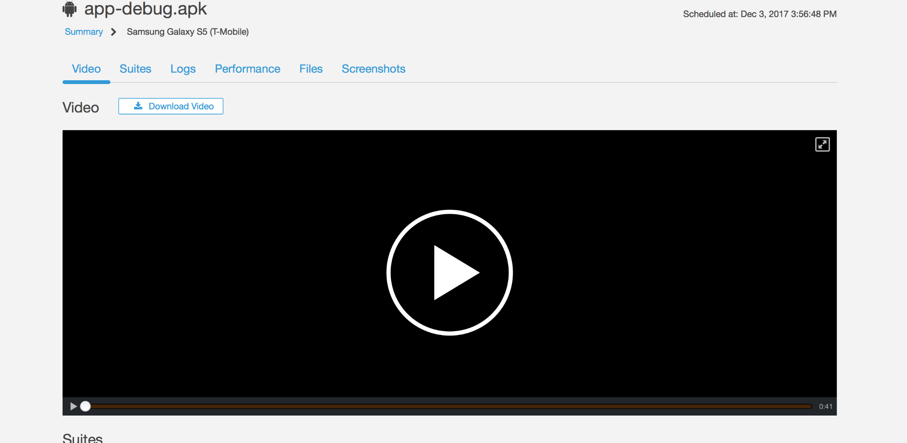

This picture below shows the test suites or process. It includes three parts: Setup Suite, Built-in Explore Suite and Teardown Suite. In Setup Suite, AWS will test the installation of our app to see if there is any glitch happening. And then in Built-in Explorer suites, the functions in our App, like button, camera and UI activity will be test. In Teardown suite, it will test whether it goes will when trying to uninstall our app. All the test suite have passed as it shown.

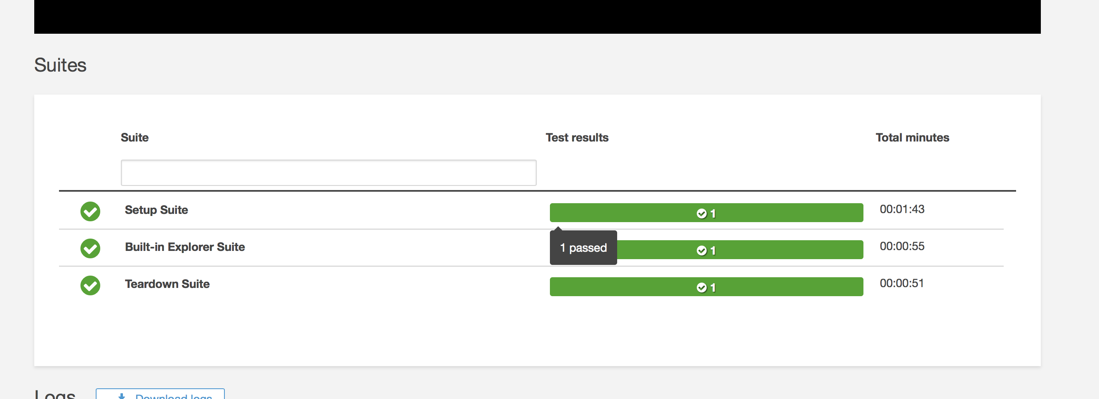

This picture below shows the test log during the process. It clearly shows every step of testing like time, PID and Message.

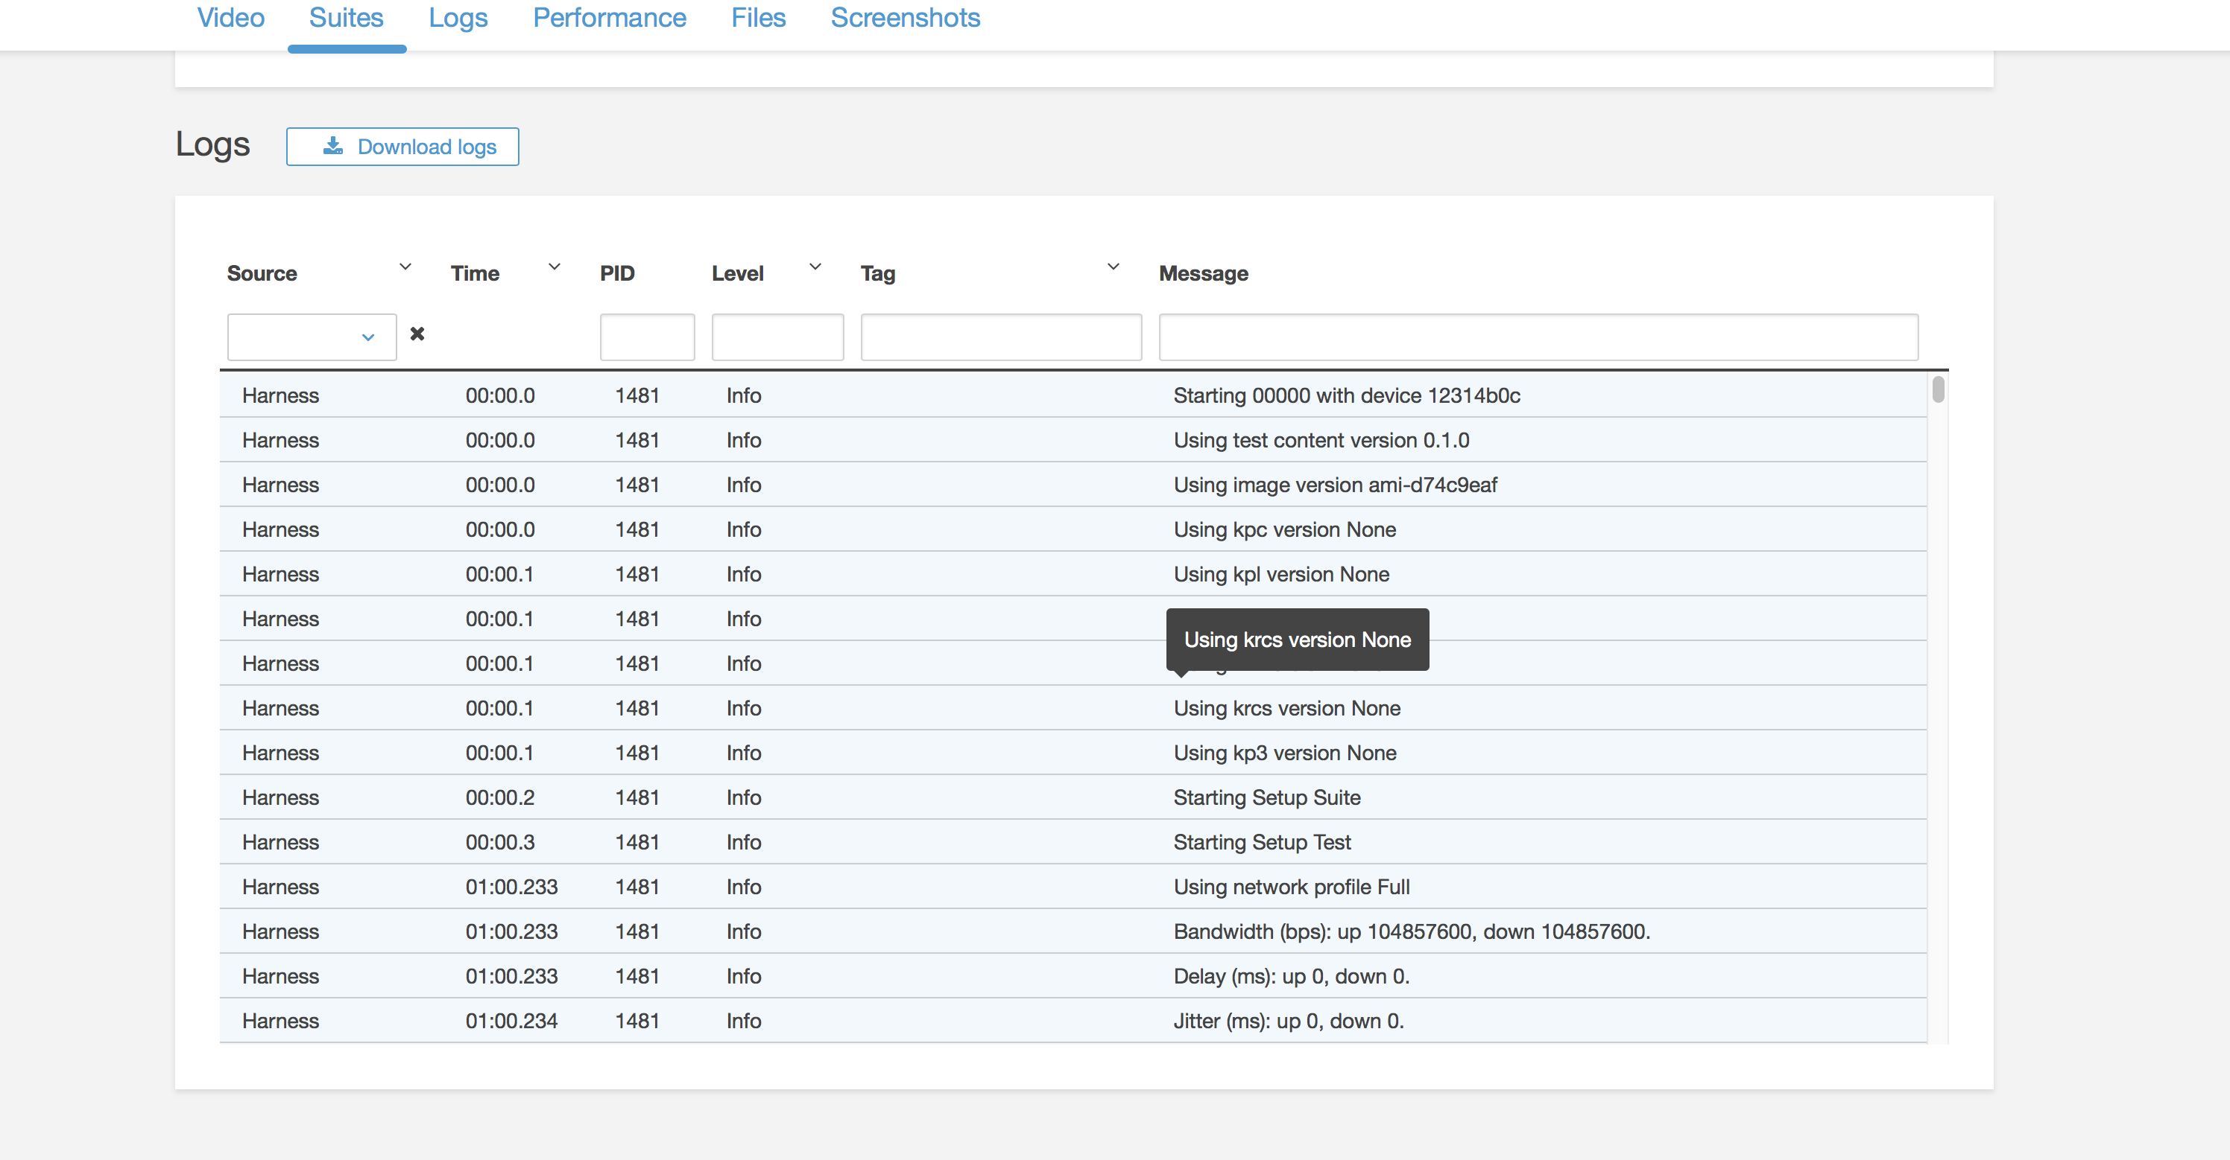

This picture shows the mobile performance during the test, including CPU usage, memory usage and Threads.

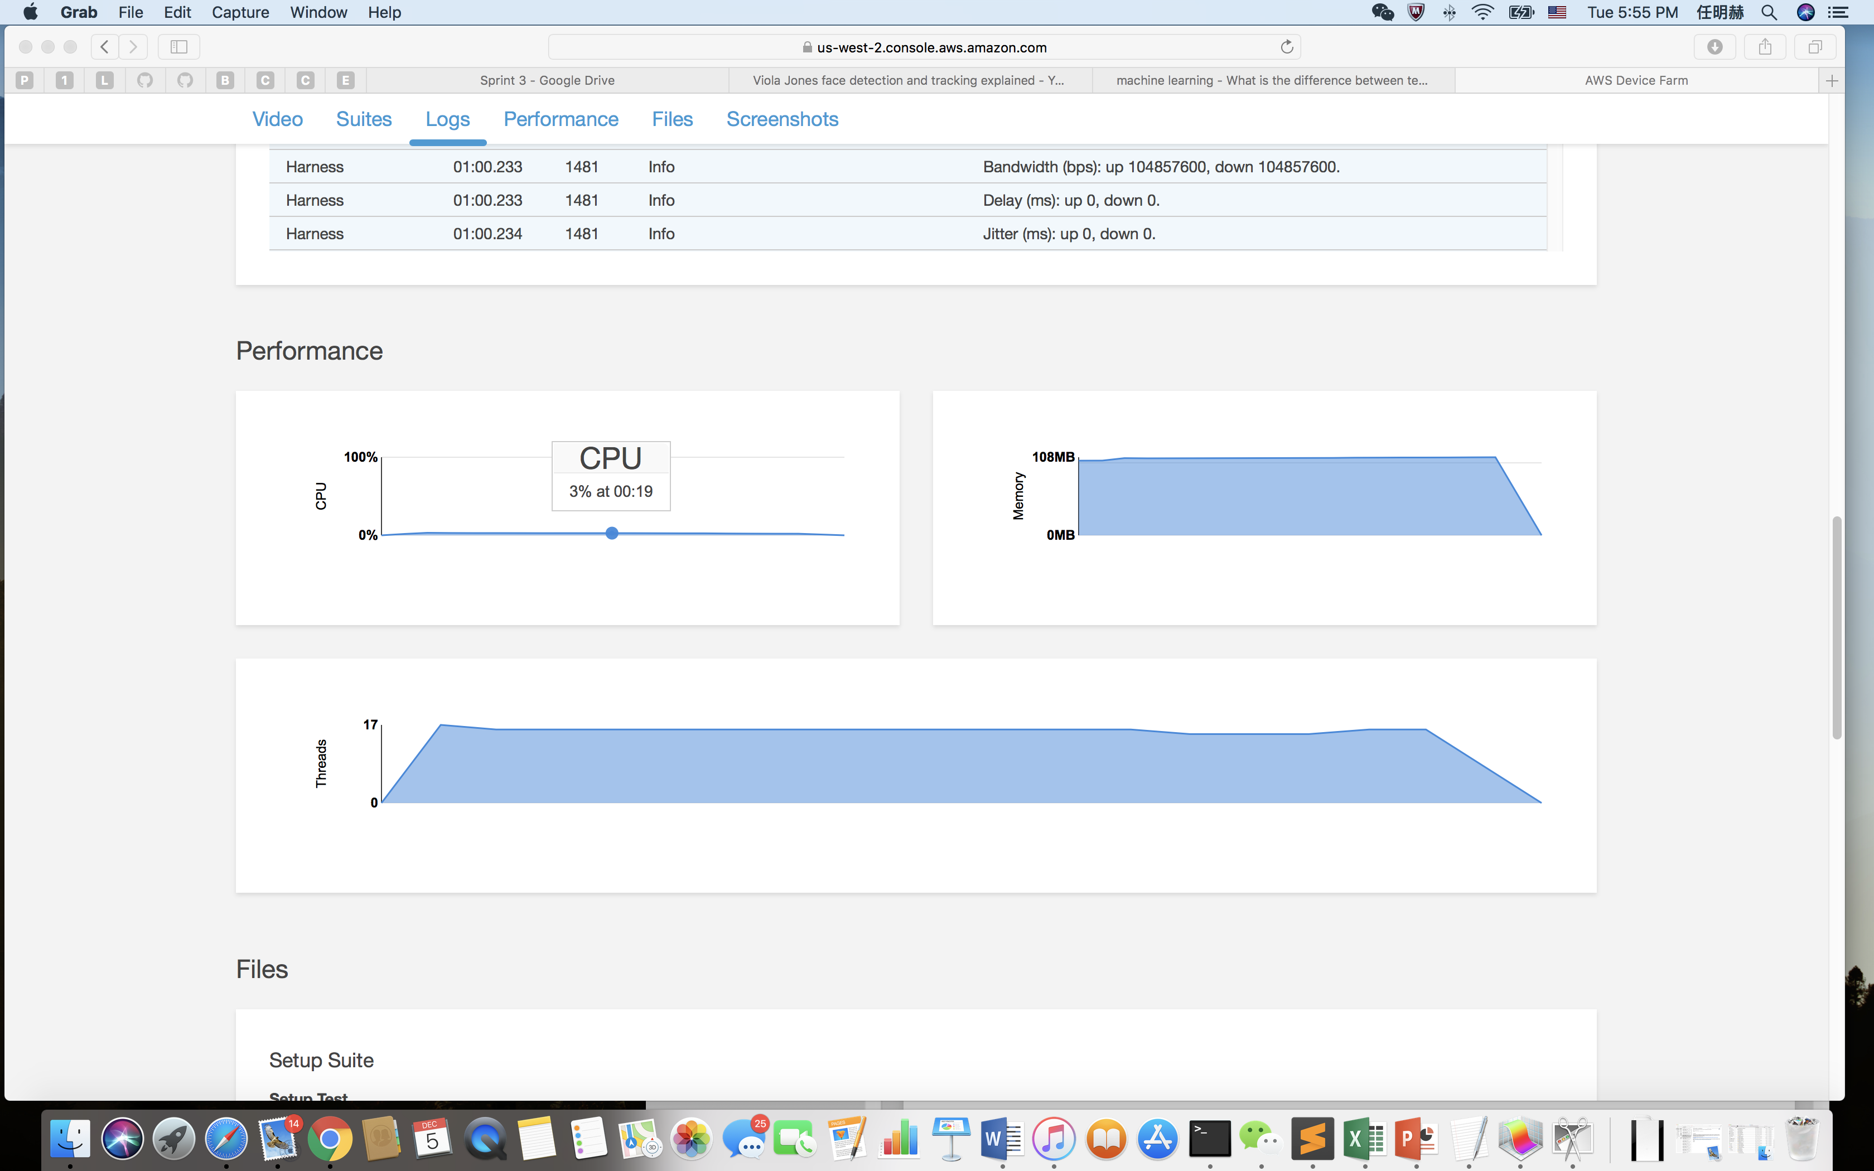

This picture shows the downloadable files concerning about the test during the while suite.

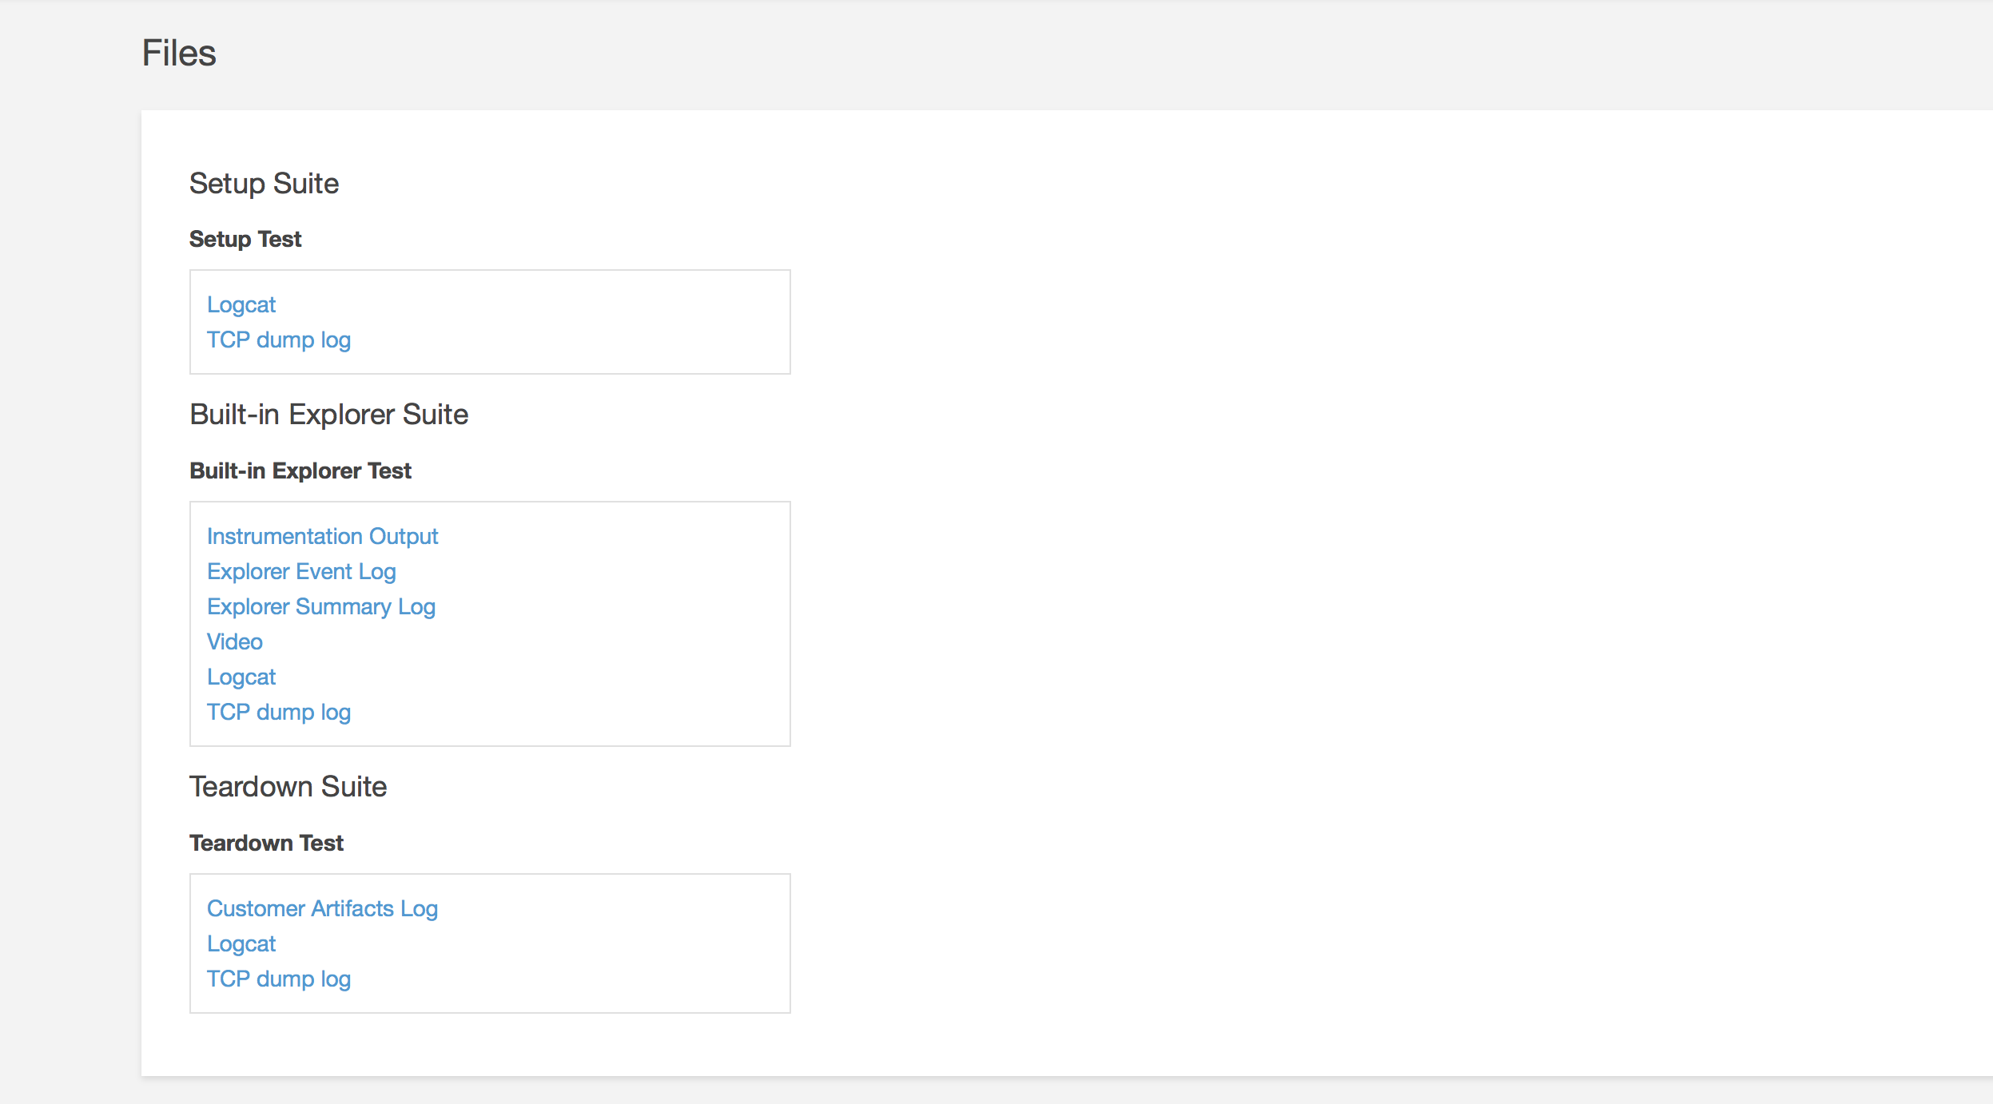

And some screen shots during test.

